2017
North Head Triathlon Race
Manual

Index
Schedule of events 3
Registration 3
Aid stations 4
Toilets 4
Race rules 4
Environmental Respect 4
Rules for family, friends and supporters 4
Transition set-up 5
Race course details and layout 6
Swim leg – 750 metres (long course) 325 metres (short course) 6
Transition 1 (Swim to run) 7
Run 1 leg - 2.9km 7
Transition 2 (Run to Bike) 8
Bike leg 7x laps, ~21km (long course), 4x laps, ~12km (short course) 9
Transition 3 (Bike to Run) 10
Run 2 leg – 5km (long course), 3km (short course) 11
Finish 12
Race results 12
Swim Gear Collection 12
Lost property 12
Contingency Plan 12
Finally…. 13

Schedule of events
Time Event
5:30 am Registration and transition opens
6:00 am Registration and transition closes – all competitors to proceed to swim start at Collins Beach
6:25 am Pre-race briefing – all competitors must clear the water and be present at race briefing
6:30 am RACE START – Collins Beach
8:30 am BIKE COURSE CLOSED/RACE FINISH - Presentation and raffle draw
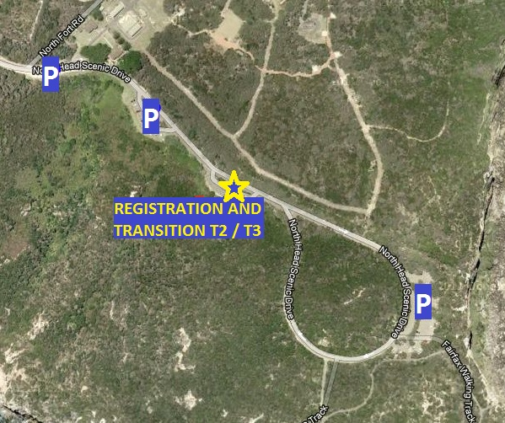
Arrival
Parking
Parking is available at North Head in the car parks to the North-west of the transition area or in the carpark on the one-way loop (see map). Please park only within marked parking spaces and do not park on the bike course.
North Head Scenic Drive
The road is OPEN to normal traffic during the race. Please remember that we DO NOT have right of way on the bike course and normal road rules will apply. Cars may be on the course (although it is usually very quiet at this time of the morning) and have every right to be there. If you are a spectator, please try to arrive before the bikes are out on the bike course – 6:40 am at the absolute latest.
Registration
Registration will be open from 5:30 am – 6:00 am on race day at the transition car park. Competitors are able to and encouraged to pre-register on the WTC website http://www.warringahtriathlonclub.com in the week leading up to the race, note the standard entry fee is available up to the Friday before each race. Late entries are available online on the Saturday and competitors are also able to register on the day both with a late entry fee.
PLEASE NOTE, the field is capped at 100 competitors, with preference given to WTC members, although nonmembers are welcome.
At registration you will be crossed checked against the registered competitor list and you will be given your numbered race timing chip to be worn on your left ankle. Please remember to return your chip at the end of the race.
Aid stations
Due to the short nature of the event, aid stations are not provided during the race and competitors are required to be self-sufficient.
Water, soft drinks, fruit, cereal and a BBQ will be provided at the completion of the race to all competitors and supporters.
Toilets
There are NO toilets at transition. The nearest toilets are located at the back of the building at the Q Station roundabout.
Race rules
The Warringah Tri Club races are sanctioned by Triathlon Australia and therefore all Triathlon Australia rules apply during the race. They can be viewed here:
http://www.triathlon.org.au/technical/race_competition_rules.htm
Some important rules to be aware of:
- Footwear must be worn at all times (other than when swimming)
- The torso of competitors must be covered at all times (i.e. no shirtless running/riding)
- The race is NON-DRAFTING. You must remain the legal distance of 7m behind the cyclist in front, except for 15 seconds allowed for overtaking. This will be policed on-course by the race director and penalties for infringements will be issued as deemed necessary.
- Helmets must be fastened before you remove your bike from its rack and must remain fastened until it is re-racked.
Environmental Respect
We are incredibly lucky to be able to race in a National Park, and must do everything we can to preserve the park. DO NOT discard any rubbish (gel wrappers, packets, bidons) on any part of the course. Competitors seen to be littering will receive an immediate disqualification from the race.
Upon completion of the race, please take all rubbish and personal belongings with you. If we leave the National Park as we found it, we will have a great race venue for many years to come.
Rules for family, friends and supporters
DO NOT bike, drive or run beside a competitor on any part of the course. It is a safety hazard and could get the competitor disqualified
DO make sure your competitor thoroughly reads this manual
DO enjoy the race and have a great time
If you are willing, PLEASE DO offer to volunteer at the race. The club is always in need of marshals, timing officials, people to run the BBQ etc. All volunteers are eligible for the lucky draw prizes.
When supporting cheer loudly and encourage everyone!!
Transition set-up
Bikes are to be racked in the T2/T3 transition area before 6am.
Please be mindful of other competitors and be conservative with your width between bikes and the layout of your transition gear to ensure that everyone can be accommodated.
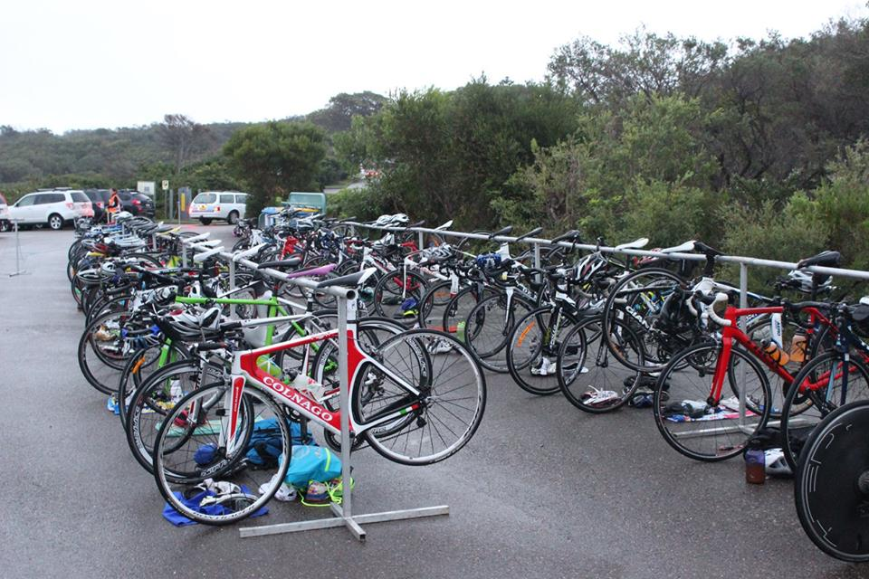
You must ensure your bike is in safe working order before entering transition. Check the general condition of your bike, paying particular attention to the brakes and tyres, and ensuring that your handlebars have bar ends.
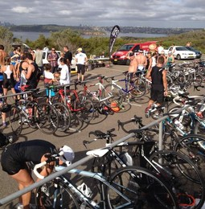
Helmets must meet AS/NZ Standards.

It is recommended that you have a drink bottle on your bike as there are no aid stations.
You will need to take your running shoes with you down to the swim start for the run back to transition.

.

Race course details and layout
Swim leg – 750 metres (long course) 325 metres (short course)
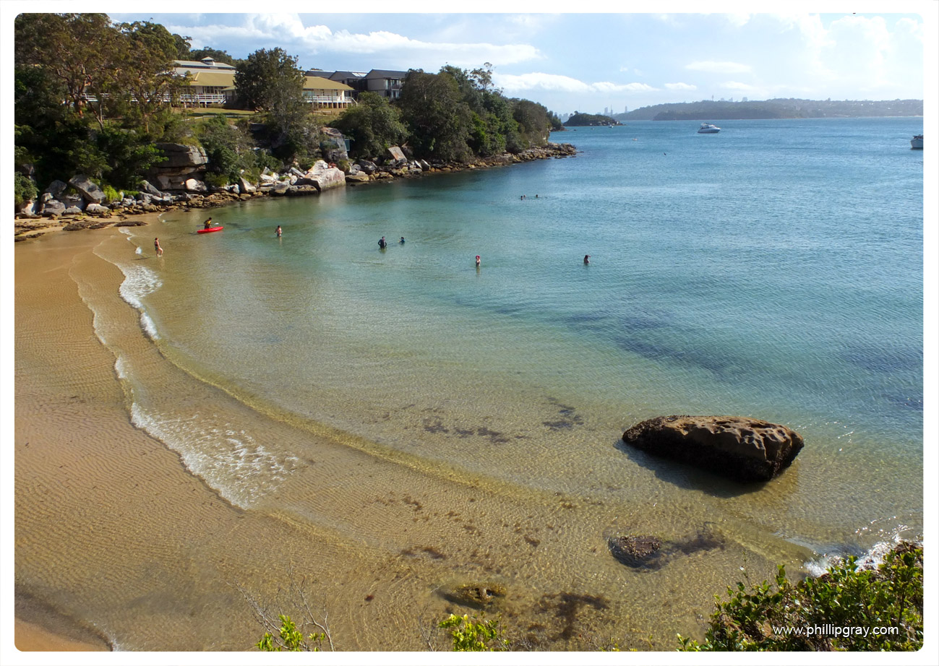
Swim start and course
The swim leg is a beach-start at Collins Beach and consists of either two laps for long course competitors or one lap for short course competitors. Long course competitors must exit the water and run around a witch’s hat on the beach before commencing their second lap.
The swim will be completed in an anti-clockwise direction keeping all buoys on your left, however this is up to the discretion of the race director and may be altered on race day. As you exit the water, you must run through the timing gates in order to record your swim split.
During the swim there is a boat providing water safety. If you require assistance during the swim leg, raise your hand and a race official will be with you as soon as possible.
Noting that Collins Beach is shallow and usually flat water and therefore generally a safe course.
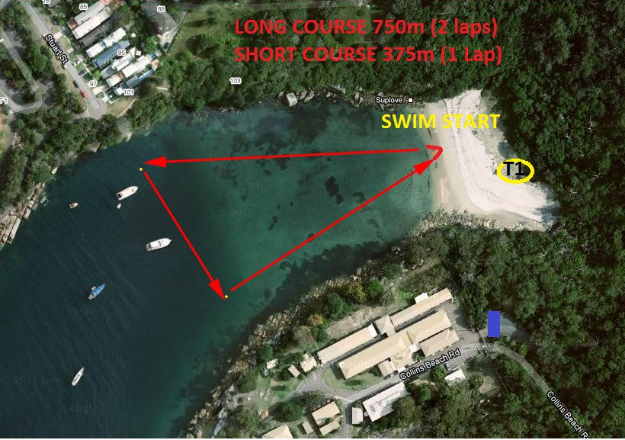
Wetsuits
Wetsuits are optional for water temperature up to 22 degrees Celsius. Above this temperature wetsuits are not permitted.

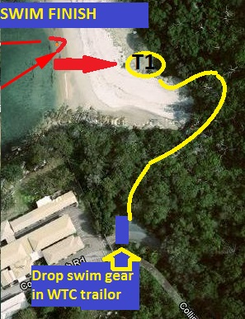
Transition 1 (Swim to run)
Collins Beach – Running shoes (& socks) should be set up prior to the swim start on the grassy area at back of beach (T1).
Remove swim equipment on the grassy area, transition into run gear and then carry wetsuits, swim cap and goggles from Collins Beach along the track to the start of Collins Beach Rd (also known as “The Snake”), where they should be thrown into the club race trailer for transportation back to the bike transition area (T2).

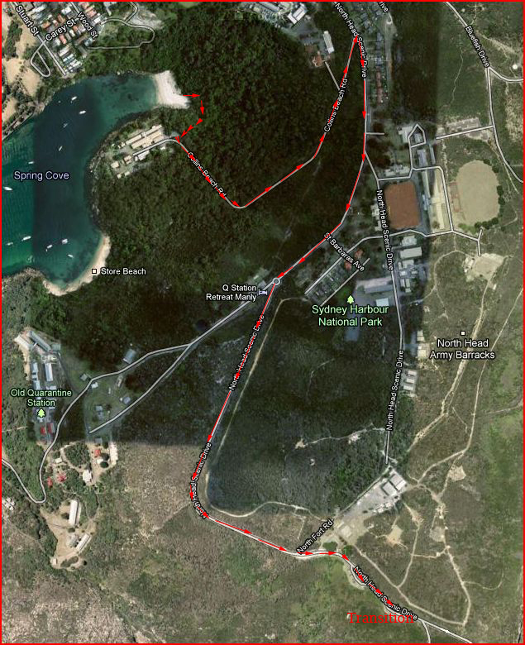
Run 1 leg - 2.9km
Competitors leave T1 and follow the bush track to the bottom of Collins Beach Rd. (Drop off swim gear) and turn left to climb “The Snake” (Collins Beach Road), this is a 1km steady climb, at the top T junction competitors turn RIGHT onto North Head Scenic Drive and continue past the roundabout until they reach T2.

Transition 2 (Run to Bike)
Upon entering T2, competitors must continue to run to the far end of transition, on the right hand side of the marked cones and through the timing gates before they reach their bike. Helmets must be on and fastened before unracking your bike.
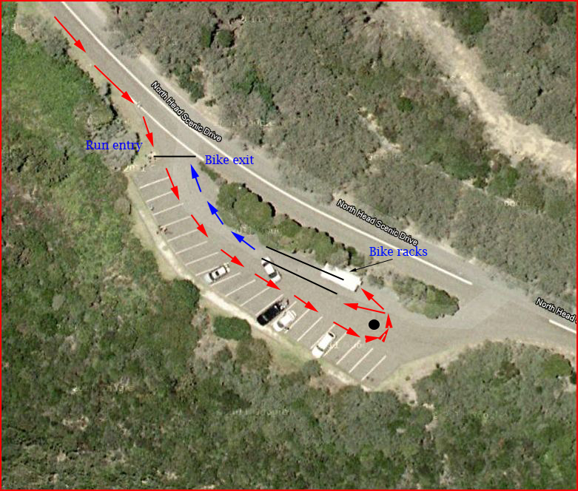
After collecting their bike, competitors must NOT mount their bike until they have crossed the marked mount line. Proceed carefully out onto North Head Scenic Drive, being mindful of other competitors and vehicles that may be coming past transition from the right.

Bike leg 7x laps, ~21km (long course), 4x laps, ~12km (short course)
Competitors exit T2 onto North Head Scenic Drive heading northwest and continue to the roundabout at the Old Quarantine station gates.
At the roundabout competitors U turn and head south back passed transition and around the North Head Scenic Drive loop. When passing the transition area after the loop, competitors have completed one lap (3km).
Competitors complete a total of seven (7) laps (long course) or four (4) laps (short course).
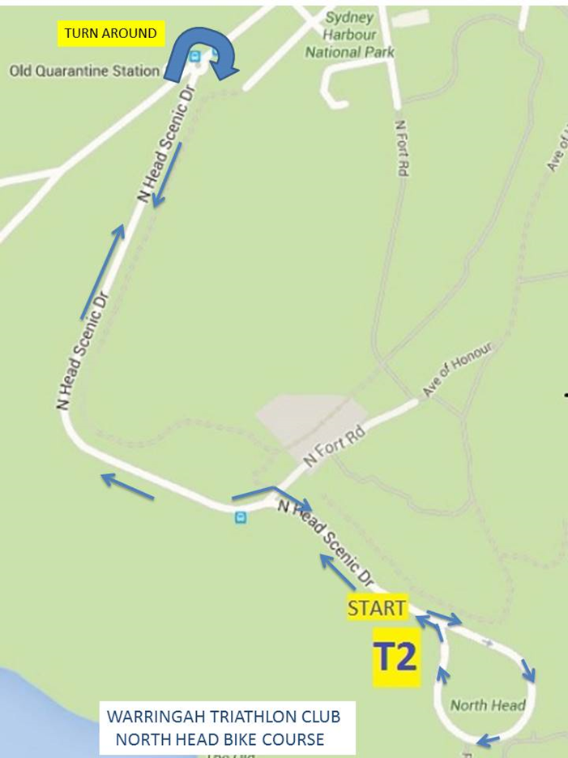
Things to be aware of during the bike leg:
- Safety first at all times
- Keep left unless overtaking
- No drafting
- When passing a competitor, simply say “on your right” to let them know you are there.
- The roundabout is off-camber and is sometimes covered in sand. Although race volunteers will clear most debris, it is the competitors’ responsibility to slow down adequately and safely negotiate the roundabout.
- There are speed humps consisting of shallow asphalt humps and plastic humps, be extremely careful negotiating around or over these humps. Adjust speed accordingly.
- Be aware the road is not closed, but will be traffic managed, be respectful to any other vehicles on course it is likely to be reciprocated.

Transition 3 (Bike to Run)
After completing the last lap of the bike leg, competitors dismount their bike at the dismount line before entering T3 to rack their bike, through the timing gates. Keep your helmet on and fastened until after racking your bike. After transitioning back into your running shoes competitors continue straight through transition out onto North Head Scenic Drive heading North West for the final run leg.
When you leave transition, be aware of bikes that may still be on the course.
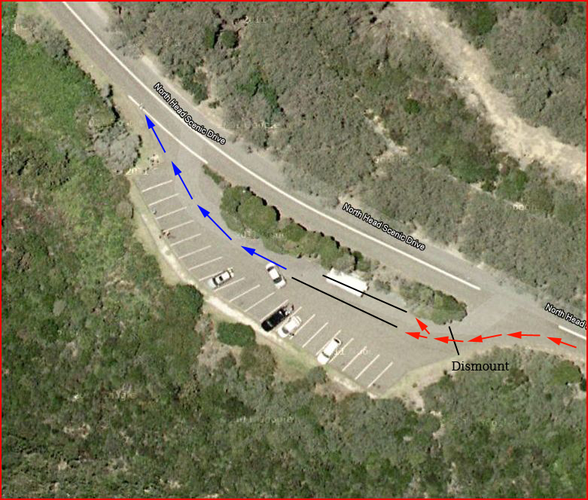

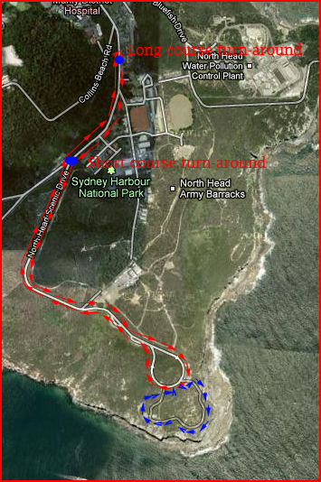
Run 2 leg – 5km (long course), 3km (short course)
Starting at transition, competitors stay on the left hand side of the road and run THROUGH the adjacent car park on their way out to the roundabout. This is to assist in avoiding bikes on the road. Continue heading north on North Head Scenic Drive, on the left of the road or unsealed road shoulder.
The short course turnaround is at the roundabout and the long course turnaround is at a clearly signed witch’s hat near the top of “The Snake”.
Returning on other side of road, competitors run back and passed the transition area.
All competitors must turn left and into the Fairfax trail carpark entry at beginning of the loop of North Head Scenic Drive.
Short course competitors then run through the car park and out of the car park exit (i.e. straight passed the Fairfax trail) and complete the road loop, staying on the left of the road heading for the finish.
Long course competitors then run through the car park and must turn left on to the Fairfax Walking trail (marked in blue on the map) and complete the trail in a clockwise direction. You have completed the trail when you come back to the same point you entered the trail. Turn left and continue around the road loop to the finish staying on the left of the road heading towards the finish.
.

Finish
As you enter the finish chute pass through the timing finish gate. After you cross the finish line there will be water, soft drinks, fruit, cereal and a BBQ provided.
You will receive congratulations for finishing and a raffle ticket for the “lucky door prizes” generously provided by our sponsors. The raffle will be drawn after the prizes for 1st, 2nd and 3rd (male and female) have been awarded.
Race results
The top 3 male and female for both the short course and long course will be recognized for their performance during the presentation. Formal race results will be posted on the Warringah Triathlon Club website following the race, usually within 48 hours. The club also runs a handicap championship to encourage competition amongst all competitors. Handicap results and the handicap point score is posted on the WTC website in the week following the race.
Swim Gear Collection
All swim gear deposited in the trailer after the swim will be brought back to the finish area and placed on the grass for collection, please collect all your gear.
Lost property
If you leave something behind after the race, all lost property will be posted on the club Facebook page, or post a note on the facebook page yourself.
Contingency Plan
Should there be extreme circumstances on the day, eg weather, physical obstruction or safety threat, that necessitate the cancelling of a leg of the race the following contingency plan will be implemented
Swim cancelled – The race will proceed as a duathlon.
Prior to 6am (leaving the registration area for swim start) the 1st leg will be a replication of the final run for each distance race in lieu of the swim and run to T1, i.e. a 3km or 5km run followed by the published bike and run legs for each distance race.
After 6am if the swim is cancelled on the beach the race will commence with the 2.9km run back from T1 to T2 for all competitors and then follow the published schedule.
Bike cancelled - The race will proceed as an Aquathon.
Swim and Run 1, as published followed by 2 laps of the standard 2nd run, eg 6km or 10km.
If it is too dangerous to run, the race will be cancelled. Generally there won’t be a decision about the cancellation of part or the entire race until race morning by the Race Committee at North Head.
Rain is not considered extreme weather!
Finally….
Please enjoy yourselves, have a safe race and hopefully meet some of the people that make WTC such a great club. If you have any further questions, please do not hesitate to approach any of the WTC officials before or after the race.
Good luck!
WTC Committee

Contact
David Wiles Vice President - Races - vicepresident@warringahtriathlonclub.com

RACE DAY CHECKLIST
…

–

Leg | Essential |  | Optional
SWIM | Race issued timing Chip  Goggles, … |  | Swim cap  Wetsuit (if applicable),
T1- RUN | Run shoes |  | Socks cap,
T2- BIKE | Bike racked and ready in Transition in appropriate gear to start |  | Sunglasses,
 | Bike shoes safely clipped onto your bike, or on the ground next to your bike |  | gloves
 | Helmet placed onto or next to your bike |  | socks
T3 - RUN | Run shoes
RECOVERY | Street Gear Bag requirements & personal belongings including warm clothing

RACE SPONSORS

